**Airplane online booking System**

***Software requirement specification (SRS)***

**1.**Group Github repository

<https://github.com/zelalemzergaw/Software-Enginering-2019>

**2**.Use case diagram

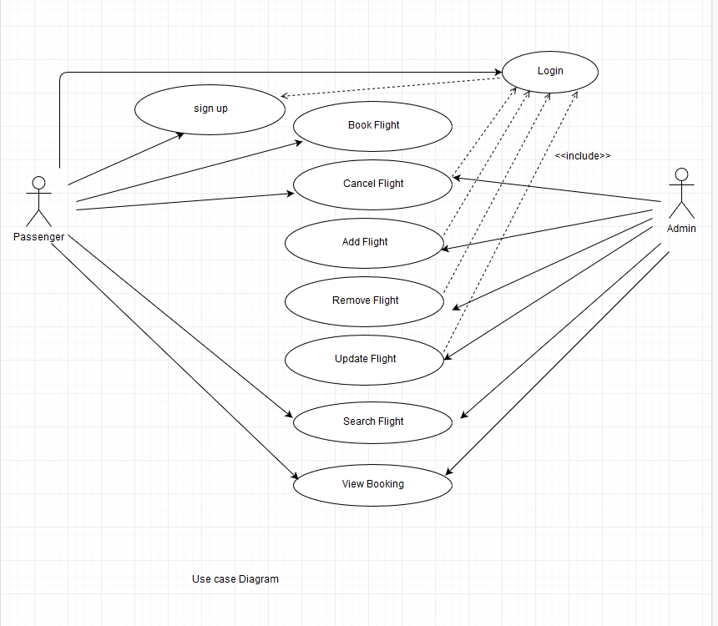

**2.Airline Flight Booking System: Use Case Description**

|  |  |  |  |
| --- | --- | --- | --- |
| **Use case Number: 1** | | | |
| **Name** | | **Book Flight** | |
| **Brief description** | | This use case helps the user(passenger) to book a flight ticket | |
| **Actors** | | Passenger(user) | |
|  | | | |
| **Preconditions:** The user not necessarily to login to book flight. | | | |
| **Flows of events** | | | |
| 1. **Basic Flows** | | | |
| **Step** | **User Actions** | | **System Actions** |
| 1 | The user(passenger) search a flight in searching box. | | The system retrieves that information from the database and returns to the user(passenger). |
| 2 | The user(passenger) fills out his information to book a flight ticket. | | The system registers his information to data base. |
| **Postconditions:** The passenger gets his confirmation number | | | |
| **Business Rules:** passenger must have valid payment method (debit card or credit card) | | | |

|  |  |  |  |  |  |  |
| --- | --- | --- | --- | --- | --- | --- |
| **Use Case Number: 2** | | | | |  | |
| **Name** | | | Search Flight | |  | |
|  | |  | | |  | |
| **Brief description this** use case helps users Search for their desired flights | | | | | | |
|  | |  |  | |  | |
| **Actors** | | | Passenger | |  | |
|  | |  | | |  | |
|  | |  |  | |  | |
| **Preconditions** | | | | |  | |
| The user should input the search criteria. | | | | |  | |
|  | |  | | |  | |
| **Flows of Events:** | | | | |  | |
| **1. Basic Flows** | | | | |  | |
|  | |  | | |  | |
|  |  | | |  | |
| **Step** | |  | **User Actions** | | **System Actions** | |
|  | |  |  | |  | |
| 1 | |  | The passenger Enters the search criteria | | The system searches the database for all related flights in that search criteria. | |
|  | |  |  | |  | |
|  | |  |  | |  | |
| 2 | |  | The passenger views all the list of flights available specified in the criteria. | | The system presents the detailed information of the list of flights that was in the result of the search query like the airline, the time of departure, and etc. | |
|  | |  |  | |  | |
|  | |  |  | |  | |
|  | |  |  | |  | |
|  | |  |  | |  | |
|  | |  | | |  | |
| **Post conditions** | | | | |  | |
| **Business Rule** | | | | |  | |
| The user should specify the required fields in the search criteria. | | | | |  | |
|  | |  | | |  | |

|  |  |  |  |
| --- | --- | --- | --- |
| **Use case Number: 3** | | | |
| **Name** | | Add Flight | |
| **Brief description** | | This use case allows the admin to Add flight in the system | |
| **Actors** | | Admin | |
|  | | | |
| **Preconditions: admin must have logged in to the system** | | | |
|  | | | |
| **Flows of events** | | | |
| 1. **Basic Flows** | | | |
| **1.1.0 Add Flight** | | | |
| Step | User Actions | | System Actions |
| 1 | The admin calls the add flight command. | | The system displays the add flight form with the field flight name. |
| 2 | The Admin fills out the form and requests the system to save the details | | The system verifies that there’s no other add flight in the database with the same name and saves the flight and returns the success message on success, generate an ID automatically to the flight or a fail message in case of failure. In case another airline exists with the name, the system returns the message indicating a duplicate entry exists. |
| **Postconditions:** The add flight is persisted in the system | | | |
|  | | | |
| **Business Rules:** No duplicate flight. A unique id is identified each flight. | | | |
|  | | | |
| **1.1.1 Update flight** | | | |
| **step** | **User Actions** | | **System Action** |
| 1 | The admin selects to view a list of flight | | The system returns a list of all flights. |
| 2 | The admin selects the flight he wants to update | | The system displays an editable flight form pre-populated with the flight details |
| 3 | The admin updates the name of the flight they want to update and requests system to save the new name. | | The system updates the record and returns the success message or a fail message on exception |
|  | | | |
| **Postconditions:** The name of the flight will be updated. | | | |
|  | | | |
| **1.1.3 Delete Flight** | | | |
| **step** | **User Actions** | | **System Action** |
| 1 | The admin selects to view a list of flights | | The system returns a list of all flights |
| 2 | The admin selects the flight he wants to delete | | The system displays a confirmation dialogue window |
| 3 | The admin selects OK on the confirmation dialog window to confirm deleting the profile | | The system deletes the flight and returns message a success confirms. |
| **Postconditions:** An flight will be deleted | | | |

|  |  |  |  |
| --- | --- | --- | --- |
| **Use case Number: 4** | | | |
| **Name** | | View Booking | |
| **Brief description** | | This use case allows the admin/passenger to View flight reservation in the system | |
| **Actors** | | Admin/ Passenger | |
|  | | | |
| **Preconditions: - admin must have logged in to the system**  **-passenger must have booked the flight and got conformation number** | | | |
|  | | | |
| **Flows of events** | | | |
| 1. **Basic Flows** | | | |
| **1.1.0 View Reservation** | | | |
| Step | User Actions | | System Actions |
| 1 | The admin/passenger calls the view reservation command. | | The system displays the text box to get flight confirmation number. |
| 2 | The admin/passenger fill out flight confirmation number and requests for flight details | | The system validates the conformation number and verifies that if there is flight reservation associated with that number, then system display flight details along with cancel flight button in case of success and fail message if conformation number does not exist. |
| **Postconditions:** | | | |
|  | | | |
| **Business Rules: -** Unique conformation number.  -Conformation number must be 10 alphanumeric character in length | | | |
|  | | | |
| **1.1 Cancel flight** | | | |
| **Name** | | Cancel Reservation | |
| **Brief description** | | This use case allows the admin/passenger to Cancel flight reservation in the system | |
| **Actors** | | Admin/ Passenger | |
|  | | | |
| **Preconditions: - admin must have logged in to the system**  **-passenger must have booked the flight and got conformation number** | | | |
|  | | | |
| **Flows of events** | | | |
| 1. **Basic Flows** | | | |
| **1.1.0 View Reservation** | | | |
| Step | User Actions | | System Actions |
| 1 | The admin/passenger calls the view reservation command. | | The system displays the text box to get flight confirmation number. |
| 2 | The admin/passenger fill out flight confirmation number and requests for flight details | | The system validates the conformation number and verifies that if there is flight reservation associated with that number, then system display flight details along with cancel flight button in case of success and fail message if conformation number does not exist. |
|  | The admin/passenger click Cancel flight button | | The system validate weather the user intended to cancel flight or not by displaying dialog box to the user. |
|  | The admin/passenger confirm the intention | | The system deletes passenger’s reservation for that flight |
| **Postconditions:** The booked flight is deleted from the system | | | |
|  | | | |
| **Business Rules: -** Unique conformation number.  -Conformation number must be 10 alphanumeric character in length | | | |

1. **Supplementary specification**

A supplementary specification captures the system requirements that are not readily captured in the use cases of the use-case model. It gives a general additional idea about the nonfunctional requirements and features such as Usability Reliability performance and all other features.

**Usability**

The online flight booking is a user-friendly system. In order to use the system, the user no need to train the software can guides him what he need to do. Our web app give for our passenger can give him better information.so the user can easily understand the app easily.

**Reliability**

Our system is consistent, could function very well and trusted.

**Performance**

Our system is compatible with any operating system. The tasks performed real fast, like less than 3 seconds to execute. It allows to multiple users to access with out being the system down.

**5.Glossarly**

It is problem domain term

**Booking a flight** – is the order of reservation of seat for flight.

**Flight** – travelling using airplanes

**Departure time**- it is the time at which flight starts or when the plane start leaving

**Boarding time-**the time at which check in starts

**Arrival time** - it is the time at which the lane start landing to its destination